**Id:193002101**

**And gate using nor**

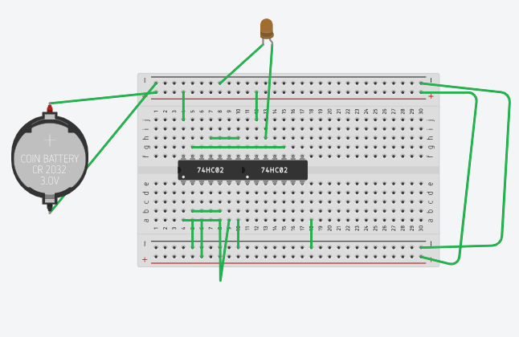

Tinkercard link: https://www.tinkercad.com/things/2jmiHjSRRnf-funky-lahdi/editel

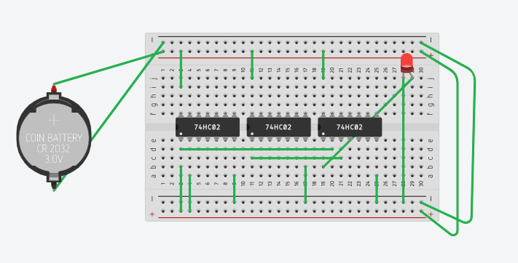**Or using Nor**

Tinkercard link: https://www.tinkercad.com/things/cFdVn3hqgXk-bodacious-krunk/editel?tenant=circuits

**Ex Or:**

